**STUDENT MANAGEMENT SYSTEM**

Group Members:

A.Yamini PL0621097

S.Nasrin Banu PL0621103

M.Sivaranjani PL0621104

J.Silvia PL0621108

Chava.Sai Hemantha PL0621123

K.Divya PL0621112

Yegi Varaha Akhil PL0621117

**Table of Contents**

1. INTRODUCTION……………………………………………………………………………….
   1. Existing System
   2. Problem Definition
   3. Why we need a new system
2. SYSTEM REQUIREMENTS………………………………………………………………..
   1. Software Specification
   2. Hardware Specification
3. PROPOSED SYSTEM……………………………………………………………..
   1. Advantages of proposed system

4. LIST OF IMPACTED MODULES………………………………………………..

* 1. Login Admin Page

4.2 Admin Home Page

4.3 Add New student

* 1. Edit and Delete student Details

4.5 Search student By course

5. UML DIAGRAMS…………………………………………………………………………..

5.1 Use case Diagram

5.2 Activity Diagram

5.3 Sequence Diagram

6. CONCLUSION…………………………………………………………………………..

**Abstract**

Student Management System helps the academic institution in managing the data of students and provides instant accessibility.  It can be used by any educational institutions or Colleges to maintain the records of students in an effective way. Here the Admin, who is handling the enrolment of students, will be responsible to add the details of the students in the database. The software has the facility to give a unique id for every student and stores the details of every student in the corresponding institutions.

**1. INTRODUCTION**

This project “Student Information Management System” provides us a simple interface for maintenance of student information. It’ll also facilitate keeping all the records of students, such as their id, name, course details etc. So all the information about an student will be available in a few seconds. Overall, it’ll make Student Information Management an easier job for the administrator and the student of any organization. The main purpose of this SRS document is to illustrate the requirements of the project Student information System and is intended to help any organization to maintain and manage its student’s personal data.

**1.1** **Existing System**

The objective of Student management System is to allow the administrator of any organization to edit and find out the personal details of a student. It can be used by educational institutes or colleges to maintain the records of students easily. Achieving this objective is difficult using a manual system as the information is scattered, can be redundant and collecting relevant information may be very time consuming. All these problems are solved using this project. Throughout the project the focus has been on presenting information in an easy and intelligible manner. The project is very useful for those who want to know about Student Information Management Systems and want to develop software / websites based on the same concept. The project provides facilities like online registration and profile creation of students thus reducing paperwork and automating the record generation process in an educational institution

**1.2** **Problem Definition**

This **student management system database** was made based on school requirements. The system can register student information. School admin can have access to the student status and information for important transaction. They can handle the data needed in managing student files as well as the transactions made by the student and staff.

**1.3** **Why we need a new system**

The existing system has the following disadvantages.

1. It is very time consuming.
2. It consumes a lot of manpower to better results.
3. lack of data security.
4. It takes a lot of time for the retrieval of data.
5. The percentage of accuracy is less.

To overcome all these limitations we propose a new system of student management system.

**2. SYSTEM REQUIREMENTS**

All computer software needs certain hardware components or other software resources to be present on a computer. These prerequisites are known as system requirements and often used as the guide line as opposed to an absolute rule.

**2.1 Software Specifications**

Operating System: Windows 8+

Frontend: HTML, CSS, JavaScript.

Backend: Core Java.

**2.2 Hardware Specifications**  
Processor: i3 Processor  
RAM: 8GB  
ROM: 250GB

**3. PROPOSED SYSTEM**

In our proposed system we have the provision for adding the details of the students by themselves. So the overhead of the school authorities and the teachers is become less. Another advantage of the system is that it is very easy to edit the details of the student and delete a student when it found unnecessary. The marks of the student are added in the database and so students can also view the marks whenever they want.

3.1 **Advantages of the proposed system:**

Our proposed system has several advantages

➢ User friendly interface

➢ Fast access to database

➢ Less error

➢ More Storage Capacity

➢ Search facility

1. **LIST OF IMPACTED MODULES**

➢ Look and Feel Environment

➢ Quick transaction

1. Login Admin Page
2. Admin Home Page
3. Add New Student
4. Update Details
5. Search By Course

**Login Admin Page:**

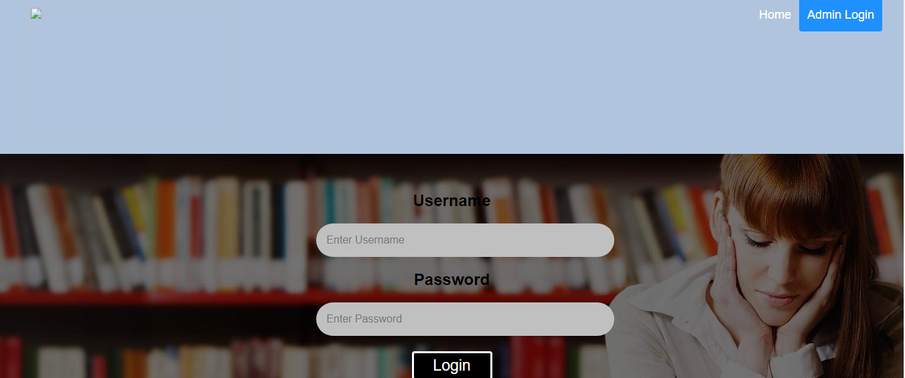

This is the page where admin can use his user name and password to login.

**Admin Home Page:**



This is the home page where the admin can select the options:

1. **Home**- Returns to the home page.
2. **Add new student**- Adding the details of new student.
3. **Update, Delete & List of student Details**- Editing and view the details of a student.
4. **Search By course**- Searching the student details for a particular course.

**Add new Student:**

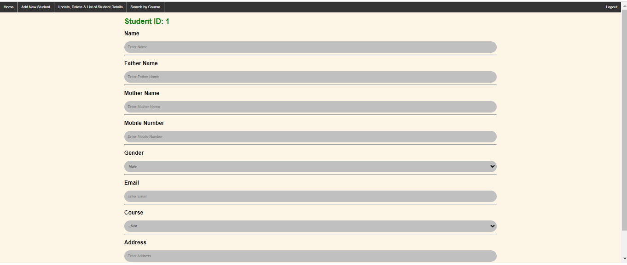

This page is used for adding the details of a student.

**Update Student Details:**

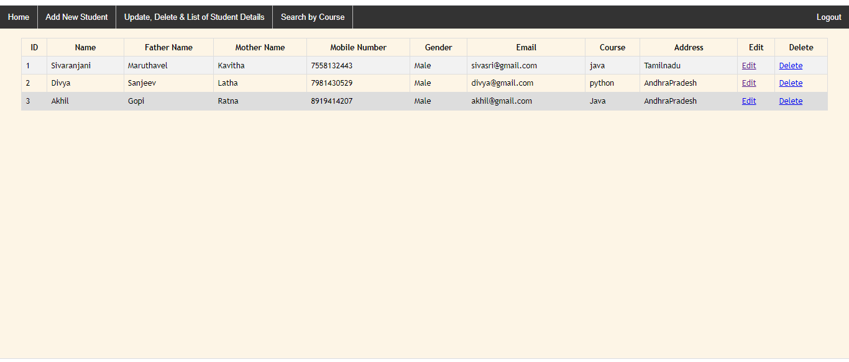

This page is used to view and edit the student details.

**Search student By course:**

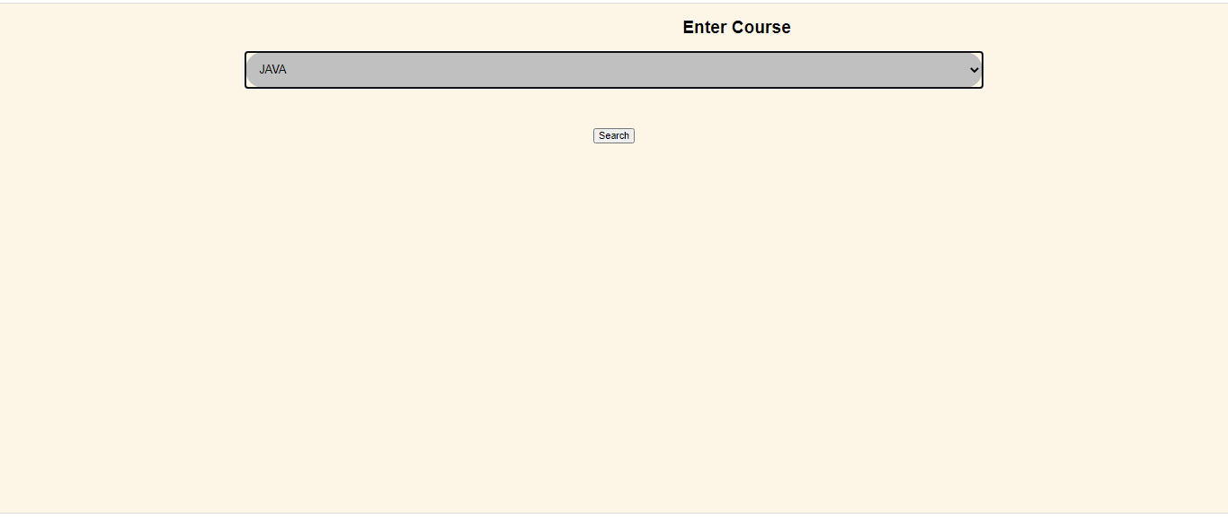

This page is used to find the student according to particular course.

**5. UML DIAGRAMS**

**5.1 Use case Diagram**

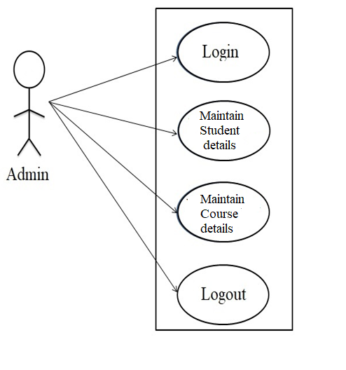

**5.2 Activity Diagram**

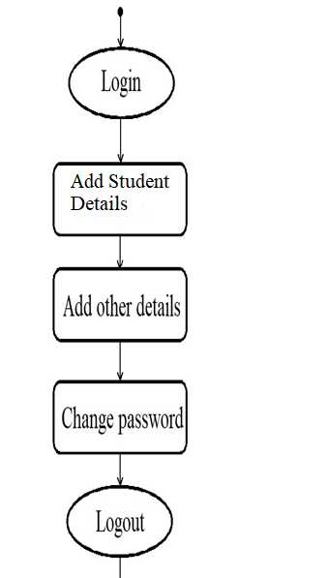

6.**CONCLUSION**

Student Management System is very useful in an institution or in college or in universities. There is no paper work in this proposed system. Supervision can be done from anywhere. This project especially minimizes human effort necessary. This application is handled by the college so there is no information leak and data will be secured. Since it is a web based application anyone can use the system anywhere at any time and it is very easy to get the necessary information without the latency. It is very useful to the students to get their report on attendance and internal assessments. Parents also get benefited more since college is going to send the notification of the student via the SMS or email will be sent to get the recent activities happen in the college. Since this application will be handled by the college whenever they need any changes in an application they can make it without the upfront investment, and the system will be more secure when it is handled by the own college